ERGO 3 Virtual Globetrotter (Unity)
User Manual
- Introduction
The Unity executable is meant to be run on the computer that the images are going to be shown on.
Prior to following this document, please read and follow the installation instructions.
- Choosing the right file
This project was developed using Unity version 6000.0.25f1.
If the you want to edit some parts of the Immersive Room experience, like the image Slideshow, or ambient music, then you have to open the project through Unity.
[Picture of how to open project on Unity]
Otherwise, you can skip to step 4.
- (Optional) Changing the image Slideshow, and Music
Editing the project images or music can be done with any computer (but preferably one with a good CPU).
If you wish to change the image Slideshow that is shown when the project is run, or the music that is played in the Immersive Room, you first need to open the Unity project file (Please, see previous step).
If you make any changes to the project, make sure to follow step 3.4.
Once you have done this, you should see the contents of the Assets folder on the bottom part of the screen. This folder contains everything that the project needs to run.
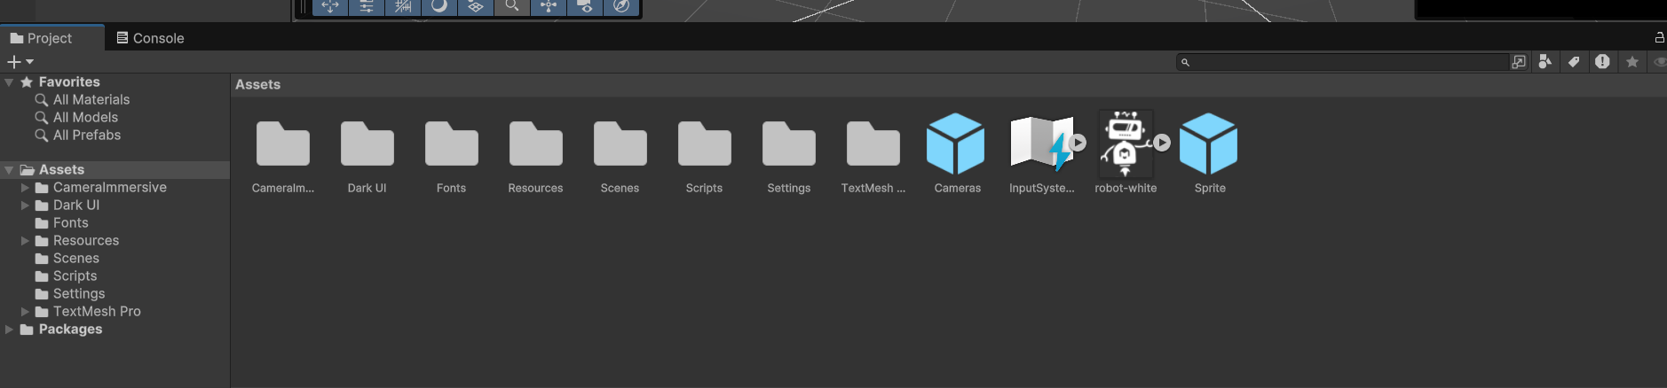
The images are located under the folder Resources.
  - Deleting Slideshow images
To delete images shown in the slideshow, make sure that you are in the Resources folder. Click once on the image you want to delete, and press the `delete` key.
Then, navigate to the folder Materials, which is also located inside the Resources folder. You should see something similar to the picture below.
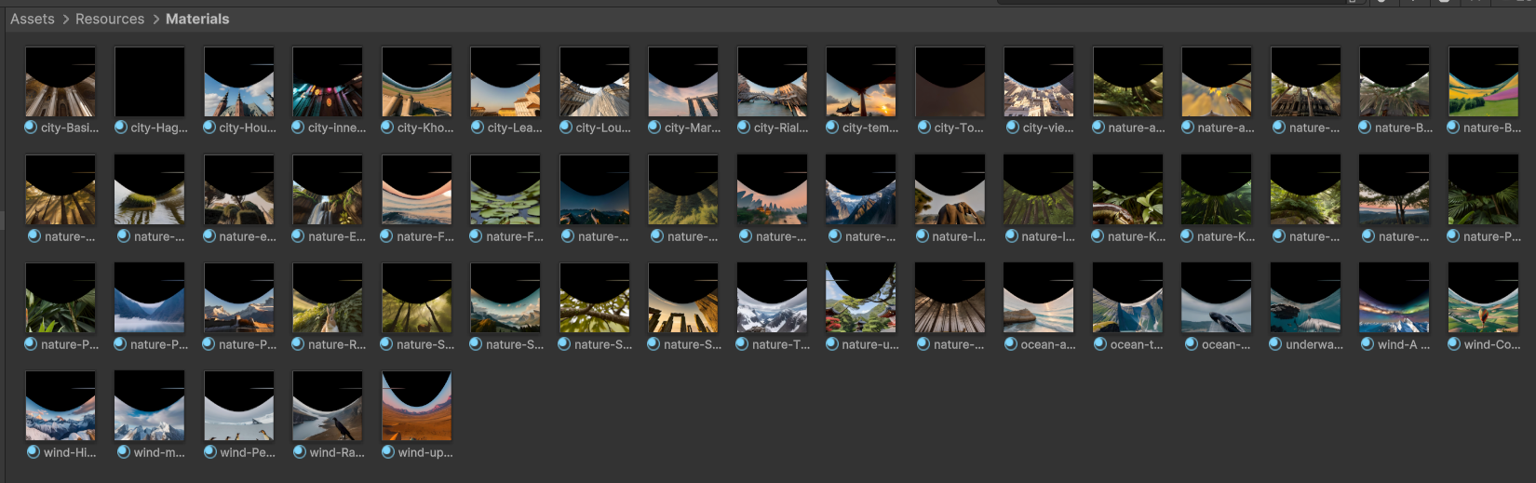
One file should have a grey picture. This is the material corresponding to the image you just deleted. Click once to select it, then press `delete` again.
  - Adding new Slideshow images
To add a new image, you first need to run the project through Unity. You can do this by pressing the `Play` button on the top side of the screen.

Rename the image you want to add to the project, by adding one of “city”, “nature”, “wind”, “ocean”, or “underwater”, followed by a dash (-), and the filename.
Example: city-new_york.jpg
This will tell the program what kind of sound to play when the image is shown. If none of these prefixes are added, the audio is picked from the “Ambient” category.
Then, navigate to the Python script, and send an image to the port 12345. The new image should be displayed on the screen.
You can now stop the project from running, by pressing the `Stop` button, which should be in place of the `Play` button.
  - Adding or deleting music
Navigate to the Resources folder. Take a look at the images present, and note that each image name is preceded by a category name (one of “city”, “nature”, “wind”, “ocean”, or “underwater”).
Now navigate to the Audio folder, which is located under Resources.
You will see 6 different folders. Each folder contains music that is played if the image currently displayed has the category in the start of its filename. The one exception to this is the Ambient category. Audio from this category will be played if the image name does not contain any category other than “city”, “nature”, “wind”, “ocean”, or “underwater”.
To add or delete music, simply navigate to the file you want to remove, click once to select it, and press the `delete` key.
  - Building a new project
To make your changes persist, you need to rebuild the project.
To do this, press the keys `ctrl`+`shift`+`b` which should open the Build Profiles window.
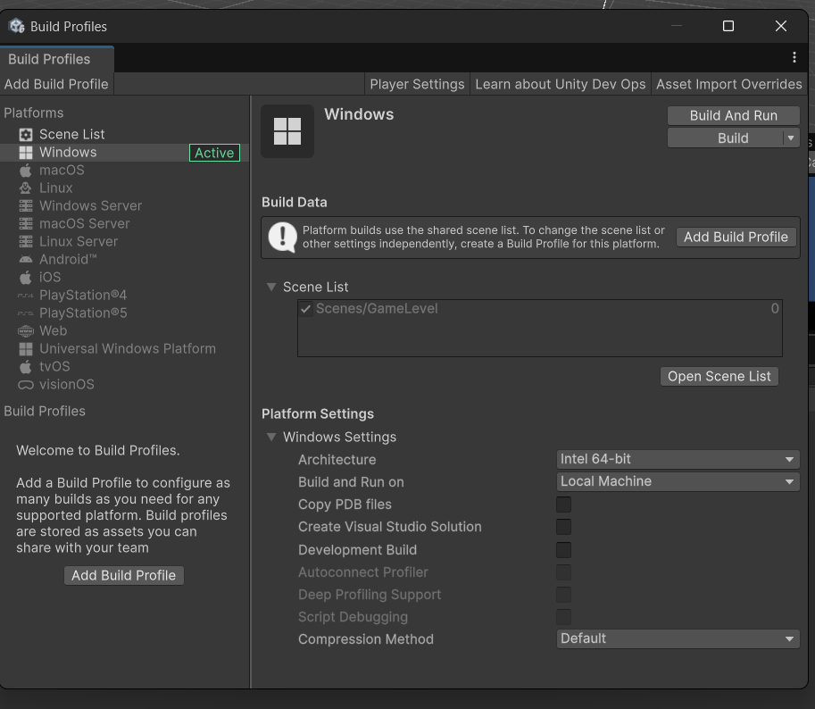
Then, press the button `Build` in the top right corner of this window.
A Windows File Explorer window should open, asking you to specify a Build folder. You can build the project anywhere, just make sure to note the folder you have chosen, as this is where the .exe file will be.

- Running the project
To run the project, navigate to the ERGO3_Virtual_Globetrotter folder, and double-click on the “Virtual Globetrotter.exe” file.

